
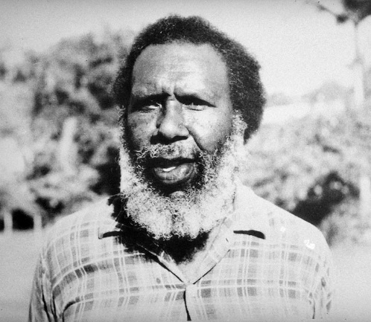
Native Title Legislation
- In 1993 the ____________ _____________ ____________ 1993 (Cwlth) was _____________.
- Principles of the Act:

What other key information do you know about Eddie Mabo and this case?

The Mabo Case
- In 1770, Captain James Cook claimed all of the east coast as _____________ territory.
- Cook could claim land under the principle of ___________ _____________, which means ____________________________________________________________________________________________________________
- The British did not recognise the ______________ and ___________ ____________ _____________ peoples as having legal title over their land because they had no written laws of ____________.
- 1882, ____________ __________ a ______________ man of ______ _______________, began ____________________________________________________________________________________________________________
- What did Eddie Mabo believe all his life? ____________________________________________________________________________________________________________
- Why did the Mer Islanders believe that they owned the land? ________________________________________________________________________________________________________________________________________________
- Who were there Torres Strait Islands under ownership and control from?
________________________________________________________________________

Definition:
Tenure: _____________________________________________________________________________________________________________________

The Mabo Decision
- The _________ _____________ decided 6-1 in ______________ of the Mer Islander ______________ and declared ________________________________________________________________________________________________________________________________________________________________________________________________________________
- This decision was based on 3 key reasons
- The principle of _________ ________ had been _____________ applied. Australia had never been __________ _________.
- In the absence of terra nullius, principles relating to ________ _________ were appropriate to be applied to land occupied and used by traditional owners.
- Native title can be recognised ________________________________________________________________________________________________.
- Why were the Meriam people able to claim native title? ____________________________________________________________________________________________________________________________________________________________________________________________________________________________________________________________________

The Mabo Case

